Russian Sports Federation for People with Intellectual Impairment
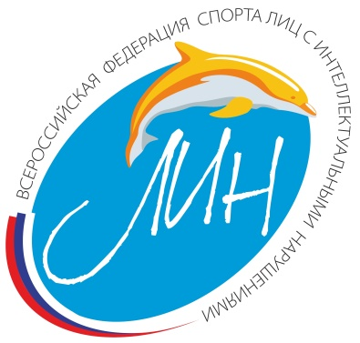
Information about Open Equestrian National Championship
for Persons with Intellectual Impairment
(10 - 15 September 2019, Kostroma, Russia)

Competition Program

Dressage Tests Grade IV
- Novice Test A
- Team Test - (20x60 arena) (updated version 2017)
- Freestyle Test ( updated version 2017)

As this is a National competition, participants from other countries should coordinate their participation with the Organizing Committee. The wish to participate should be sent to: paramon66@mail.ru before August 1, 2019, as the participants from other countries will need visas and it takes time.
Competitions will take place at Kostroma Race Track.
Accommodation, meals, transport and horses rent expenses should be covered by participants.
Following costs will be charged:
- 120 Euro per person/per day, including accommodation, meals, culture program.
- Horse rent: 50 Euro per day/horse.
- Bus transfer Moscow Airport – Kostroma – Moscow Airport, the cost – on request
The suggested hotel ARISTOKRAT is located 100 m from the sports venue.
The Program will be all Grade IV tests.
September 10 Arrival into Moscow Airport. Transfer to Kostroma by
bus. Accommodation at hotel ARISTOKRAT.

September 11 Training and familiarization with horses

September 12 Novice Test

September 13 Team Test

September 14 Freestyle Test
City sightseeing tour incl. Ipatyev monastery

September 15 Transfer from Kostroma to Moscow Airport.
Departure by plane.
A team will consist of 3 athletes.
Maximum 2 horses per rider.
Riders have to have a National Eligibility.

